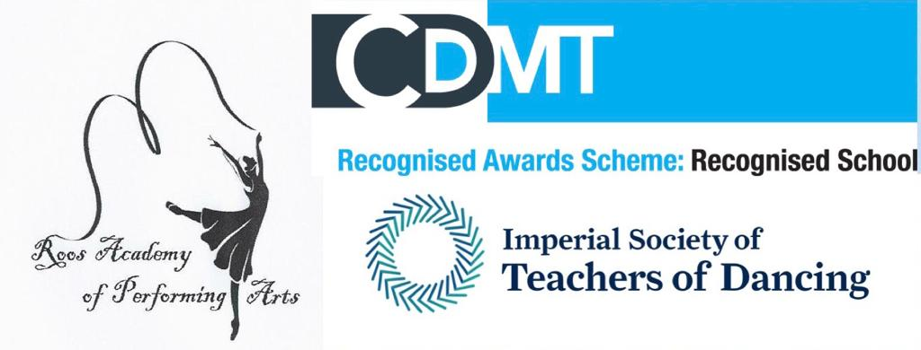
AUTUMN TERM 2021
TERM STARTS ON SATURDAY 11TH SEPTEMBER

MONDAYS – GREENWICH - UPSTAIRS |  |  |  |  |  |  | MONDAYS – GREENWICH - DOWNSTAIRS
4.00 – 4.45 |  | PRIMARY BALLET |  |  | £85.00 |  | 4.00 – 4.45 |  |  | PRIMARY BALLET EXAM |  | £85.00
4.45 – 5.15 |  | GRADE 1 MODERN - E |  |  | £80.00 |  | 4.45 – 5.15 |  |  | GRADE 1 MODERN - Y |  | £80.00
5.15 – 6.00 |  | GRADE 1 BALLET |  |  | £85.00 |  | 5.15 – 5.45 |  |  | PRIMARY TAP |  | £80.00
6.30 – 7.15 |  | GRADE 4 BALLET |  |  | £85.00 |  | 5.45 – 6.15 |  |  | GRADE 3 TAP |  | £80.00
7.15 – 7.45 |  | GRADE 3 MODERN- E |  |  | £80.00 |  | 6.15 – 6.45 |  |  | GRADE 1 TAP |  | £80.00
WEDNESDAYS - GREENWICH - UPSTAIRS |  |  |  |  |  |  | WEDNESDAYS- GREENWICH - DOWNSTAIRS
3.45 – 4.30 |  | ADV 1 MODERN |  |  | £85.00 |  | 4.00 – 4.30 |  |  | GRADE 3 TAP |  | £80.00
4.30 – 5.00 |  | GRADE 4 MODERN- E |  |  | £80.00 |  | 4.30 – 5.00 |  |  | GRADE 5 TAP - E |  | £80.00
5.00 – 5.45 |  | GRADE 5 BALLET - E |  |  | £85.00 |  | 5.00 – 5.45 |  |  | GRADE 6 MODERN |  | £85.00
5.45 – 6.15 |  | GR 6/I.F. |  |  | £80.00 |  | 5.45 – 6.15 |  |  | INTER MODERN |  | £80.00
6.15 – 7.00 |  | POINTEWORK |  |  | £80.00
7.00 – 7.45 |  | INTER BALLET |  |  | £85.00
7.45 – 8.30 |  | ADV 1 BALLET |  |  | £85.00
THURSDAYS - GREENWICH - UPSTAIRS |  |  |  |  |  |  | THURSDAYS - GREENWICH - DOWNSTAIRS
4.00 – 4.30 |  | 3 – 5 YEARS BALLET |  |  | £80.00
4.30 – 5.15 |  | GRADE 2 BALLET |  |  | £85.00 |  | 4.30 – 5.15 |  |  | GRADE 2 TAP |  | £85.00
5.15 – 5.45 |  | GRADE 2 MODERN- E |  |  | £80.00 |  | 5.15 – 6.00 |  |  | ADV 2 TAP |  | £85.00
5.45 – 6.15 |  | GRADE 3 MODERN |  |  | £80.00 |  | 6.00 – 6.45 |  |  | GRADE 4 TAP |  | £85.00
6.15 – 7.00 |  | GRADE 3 BALLET |  |  | £85.00 |  | 6.45 – 7.15 |  |  | POINTEWORK |  | £80.00
7.15 – 7.45 |  | GRADE 6 MODERN |  |  | £80.00
7.45 – 8.30 |  | GRADE 5 BALLET- EXAM |  |  | £85.00
FRIDAYS – GREENWICH – EXAM COACHING |  |  |  |  |  |  | FRIDAYS – GREENWICH - FESTIVAL
4 - 8 |  | EXAM COACHING |  |  | TBC |  | 4 - 8 |  |  | PRIVATE LESSONS |  | TBC
SATURDAYS – SHREWSBURY HOUSE |  |  |  |  |  |  | SATURDAYS – SHREWSBURY HOUSE
9.00 – 9.45 | GRADE 3 BALLET |  | £85.00 | 9.30 – 10 |  | M.T. SENIORS |  | £80.00
9.45 – 10.15 | GRADE 3 MODERN |  | £80.00 | 10 – 10.30 |  | M.T. JUNIORS |  | £80.00 | 10 – 10.30 |  | BODY CONDITIONING - Seniors |  | £80.00
10.30 – 11 | GRADE 1 BALLET |  | £80.00 | 10.30 - 11 |  | M.T. INTERS |  | £80.00 | 10.30 - 11 |  | KICKS & TURNS - Seniors |  | £80.00
11 -11.30 | GRADE 2 BALLET |  | £80.00 |  |  |  |  |  | 11 – 11.30 |  | BODY CONDITIONING - Inters |  | £80.00
11.30 – 12 | GRADE 1 MODERN |  | £80.00 |  |  |  |  |  | 11.30 - 12 |  | MODERN COACHING
12 – 12.30 | PRIMARY BALLET |  | £80.00 |  |  |  |  |  | 12 – 12.30 |  | GR 1 TAP - E |  | £80.00
12.30 – 1 | PRE – PRI BALLET |  | £80.00
1.00 – 1.30 | 3 – 5 YEARS |  | £80.00

ALL EXISTING PUPILS WILL BE GIVEN THEIR TIMETABLE DURING LAST WEEK OF TERM

